Improved Mass Spectrometry-based activity assay reveals oxidative and metabolic stress as sirtuin-1 regulators
Supplemental Information
Di Shao^{#1}, Chunxiang Yao^{#1,2}, Maya H. Kim¹, Jessica Fry^{1,a}, Richard A. Cohen¹, Catherine E. Costello², Reiko Matsui¹, Francesca Seta¹, Mark E. McComb², Markus M. Bachschmid^{1,2}
¹Vascular Biology Section, Whitaker Cardiovascular Institute, ²Cardiovascular Proteomics Center, Boston University School of Medicine, Boston, MA, USA.
ªPresent address: Department of Natural Sciences and Mathematics, Curry College, Milton, MA, USA
#These authors have contributed equally

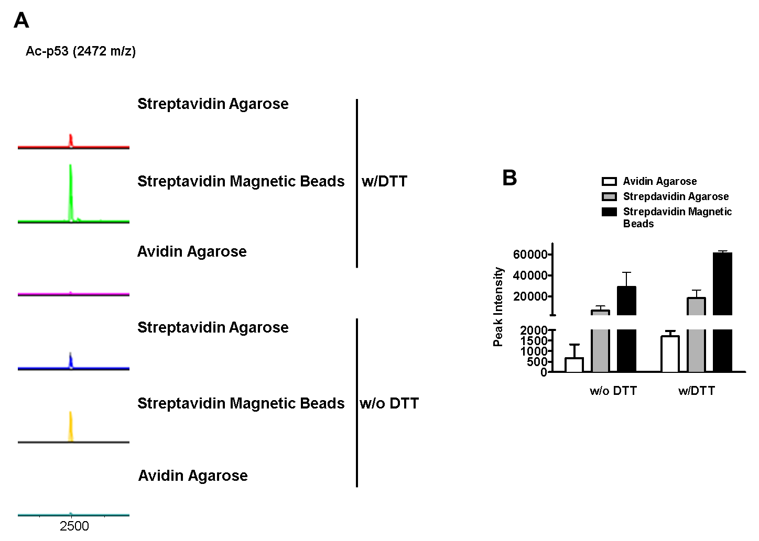

Supplemental Figure 1. Comparison of elution efficiencies of different beads.
A) Representative MS assay of H₂O elution with or without 5 mM DTT using streptavidin or magnetic beads. B) Ac-p53 peak intensities were calculated from the mass spectra. Data are presented as means ± SD of N=3.

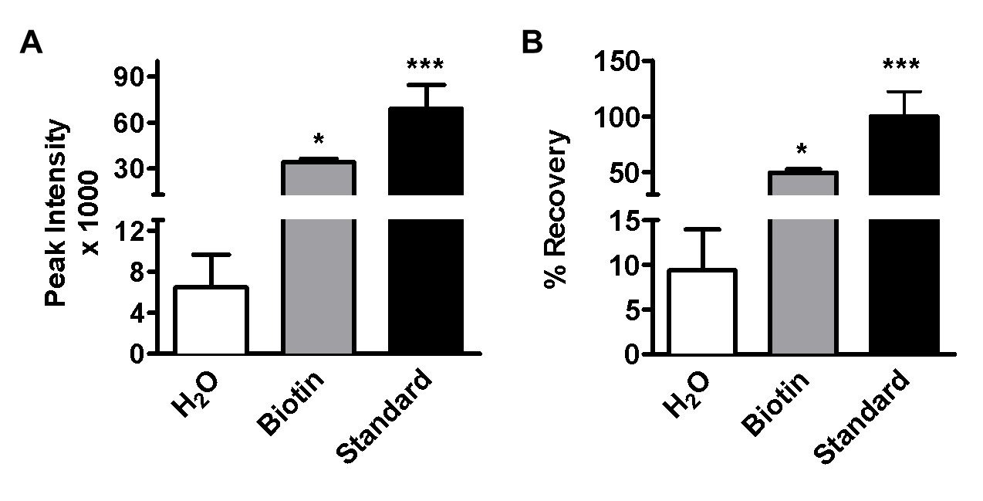

Supplemental Figure 2. Comparison of p53 peptide recoveries of different elution methods.
A) The biotin-labeled Ac-p53 peptide was eluted with H₂O, 5 mM DTT, or 5 mM biotin in Tris buffer and the peak intensities were obtained from the mass spectra and compared with Ac-p53 peptide standard. B) Percentage of recovery of each elution method was calculated and expressed relative to the Ac-p53 peptide standard. Data are presented as means ± SD of N=3 and were analyzed with one-way ANOVA followed by Bonferroni’s post-test (*p<0.05, ***p<0.001).

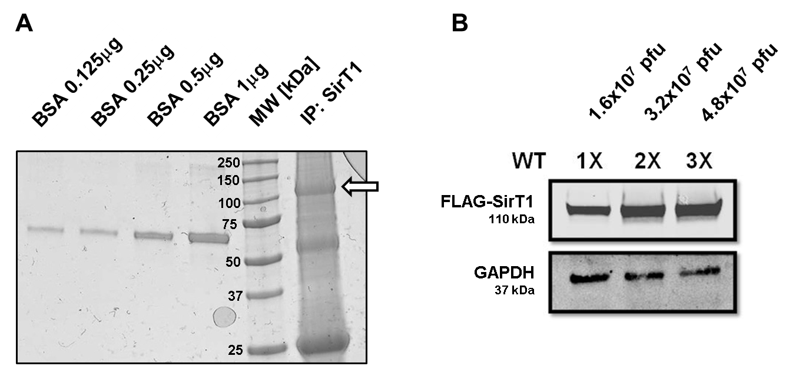

Supplemental Figure 3. SirT1 expression levels in HepG2 cells.
A) 1.3x10⁵ HepG2 cells were infected with 1.6x10⁷ pfu of adenovirus, and FLAG-SirT1 was compared with BSA after immunoprecipitation using Coomassie blue staining. The arrow indicates FLAG-SirT1. B) Western blot analysis of SirT1 expression levels in HepG2 cells infected with different amounts of adenovirus.

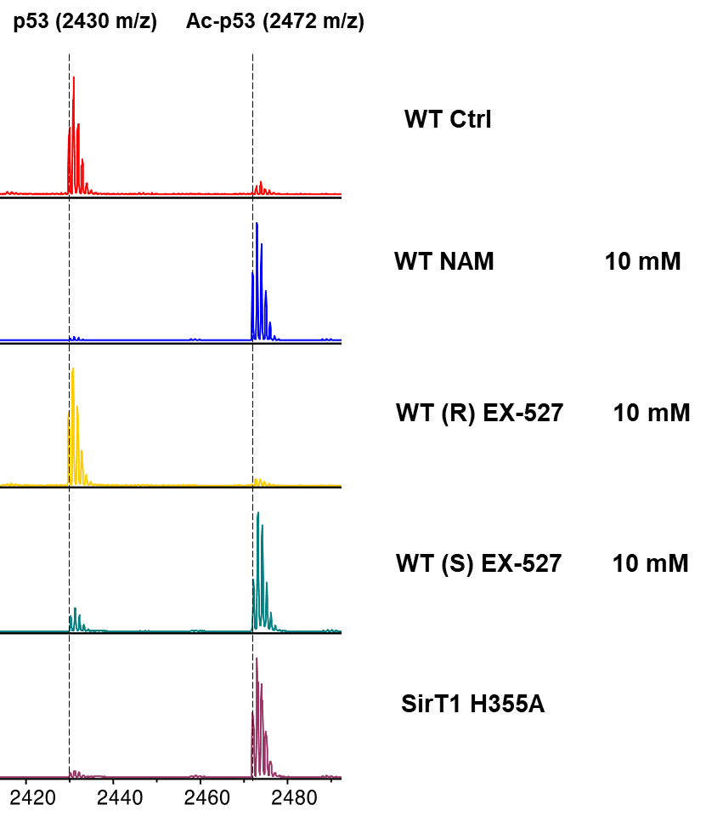

Supplemental Figure 4. Representative RAMSSAY of SirT1 inhibitors and dominant negative mutant SirT1.
HepG2 cells overexpressing FLAG-SirT1 or dominant negative FLAG-SirT1 (SirT1 H355A) were treated with 10 mM NAM, 10 mM active inhibitor EX-527 S-enantiomer, or 10 mM negative control EX-527 R-enantiomer. A representative mass spectrum is shown for each assay.

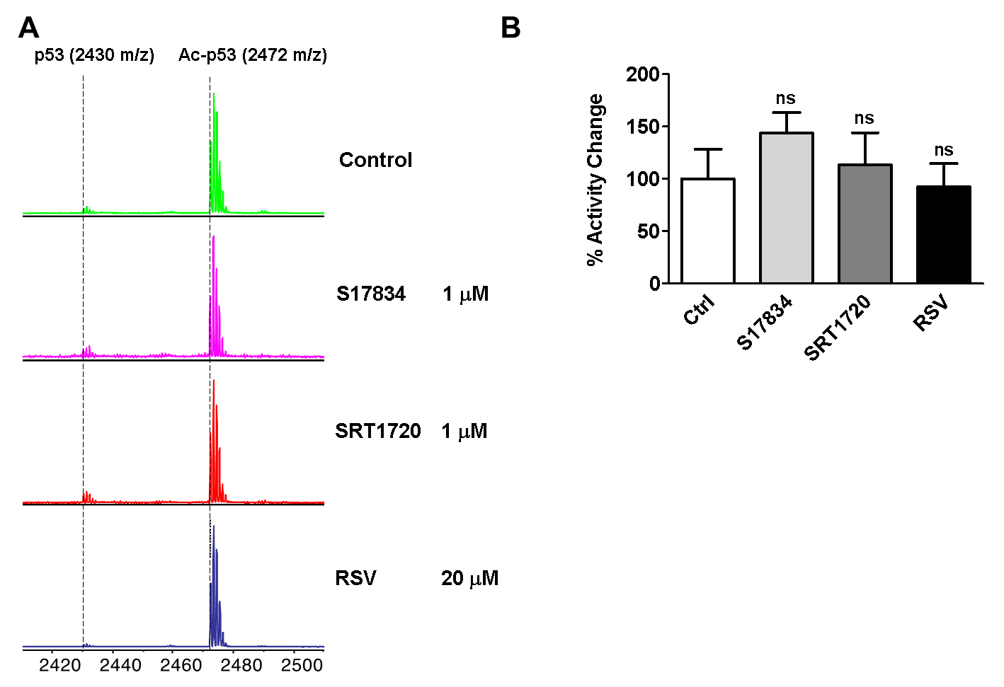

Supplemental Figure 5. Effects of putative SirT1 activators in HepG2 cells.
A) HepG2 cells were treated with 1 μM S17834, or 1 μM SRT1720, or 20 μM resveratrol (RSV). B) p53/Ac-p53 peak intensity ratios were calculated. Data are presented as means ± SD of N=3 and were analyzed with one-way ANOVA followed by Bonferroni’s post-test (ns = non-significant).

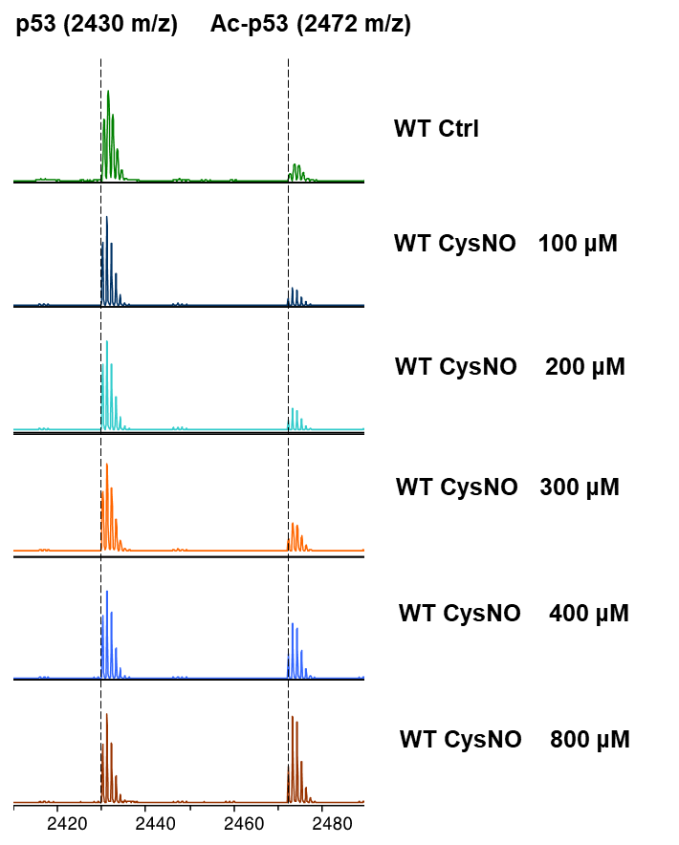

Supplemental Figure 6. RAMSSAY of HepG2 cells exposed to CysNO.
HepG2 cells overexpressing FLAG-SirT1-WT were treated with increasing concentrations of S-nitrosocysteine (CysNO 0-800 μM) overnight. A representative mass spectrum is shown for each assay.

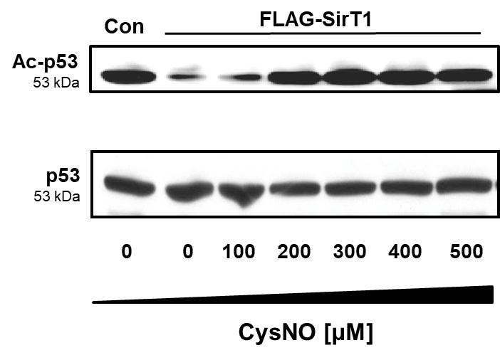

Supplemental Figure 7. p53 acetylation in HepG2 cells exposed to CysNO.
HepG2 cells overexpressing FLAG-SirT1-WT were treated with increasing concentrations of S-nitrosocysteine (CysNO 0-500 μM) overnight. p53 and acetylated (Ac-) p53 expression levels were analyzed with Western blot. The ratio of Ac-p53 to p53 between the blots denotes the results of the densitometric analysis.

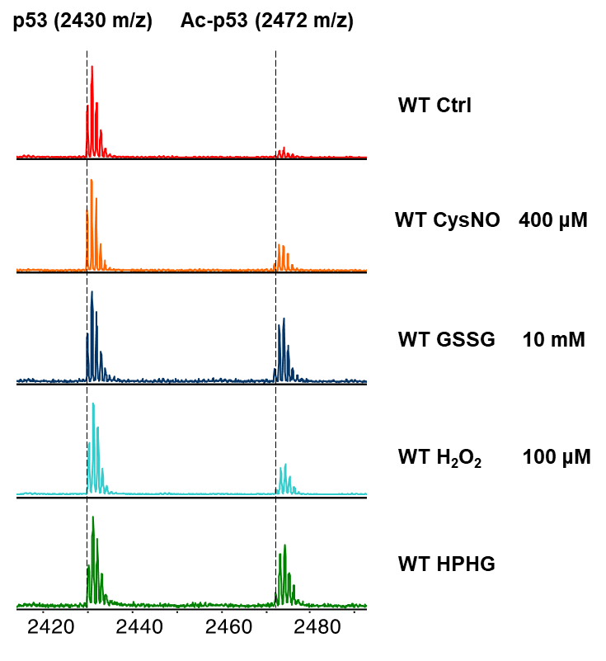

Supplemental Figure 8. RAMSSAY in HepG2 cells exposed to oxidative stress.
HepG2 cells were treated with 400 μM CysNO, 500 μM GSSG ethyl ester, 100 μM H₂O₂, or 400 μM HPHG overnight. A representative mass spectrum is shown for each assay.
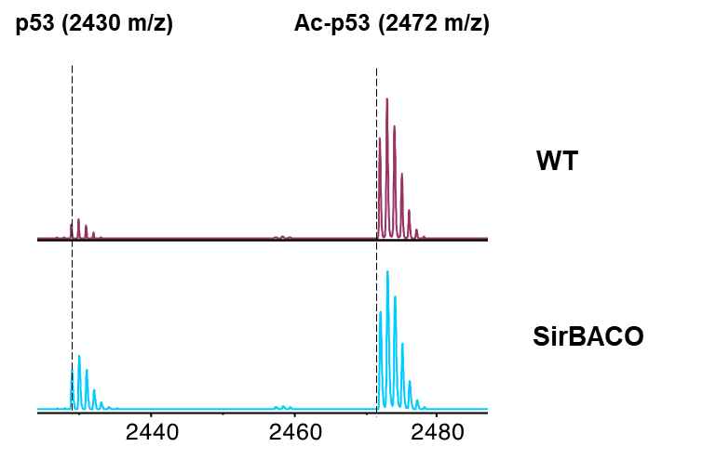

Supplemental Figure 9. RAMSSAY in WT and SirBACO mice.
Endogenous SirT1 activity in liver homogenates of WT and SirBACO mice detected with mass spectrometry. A representative mass spectrum is shown for each assay.
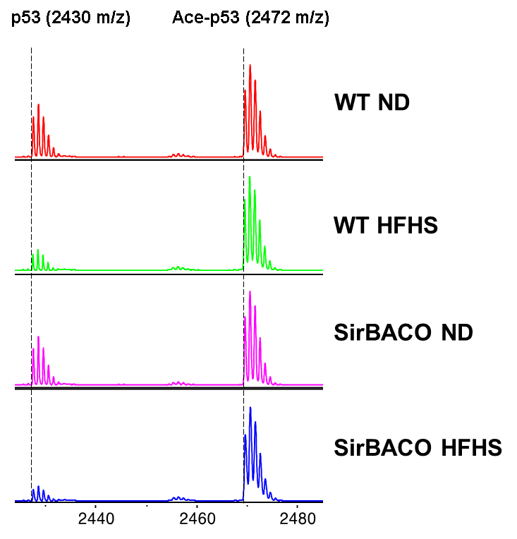

Supplemental Figure 10. RAMSSAY in liver homogenates of WT and SirBACO mice fed ND or HFHS diet.
Endogenous SirT1 activity in livers of WT and SirBACO mice fed ND or HFHS diet, detected with mass spectrometry. A representative mass spectrum is shown for each treatment condition.

