Supplement: The contribution of the locus coeruleus-norepinephrine system in the emergence of defeat-induced inflammatory priming

Finnell JE, Moffitt CM, Hesser LA, Harrington E, Melson MN, Wood CS, Wood SK

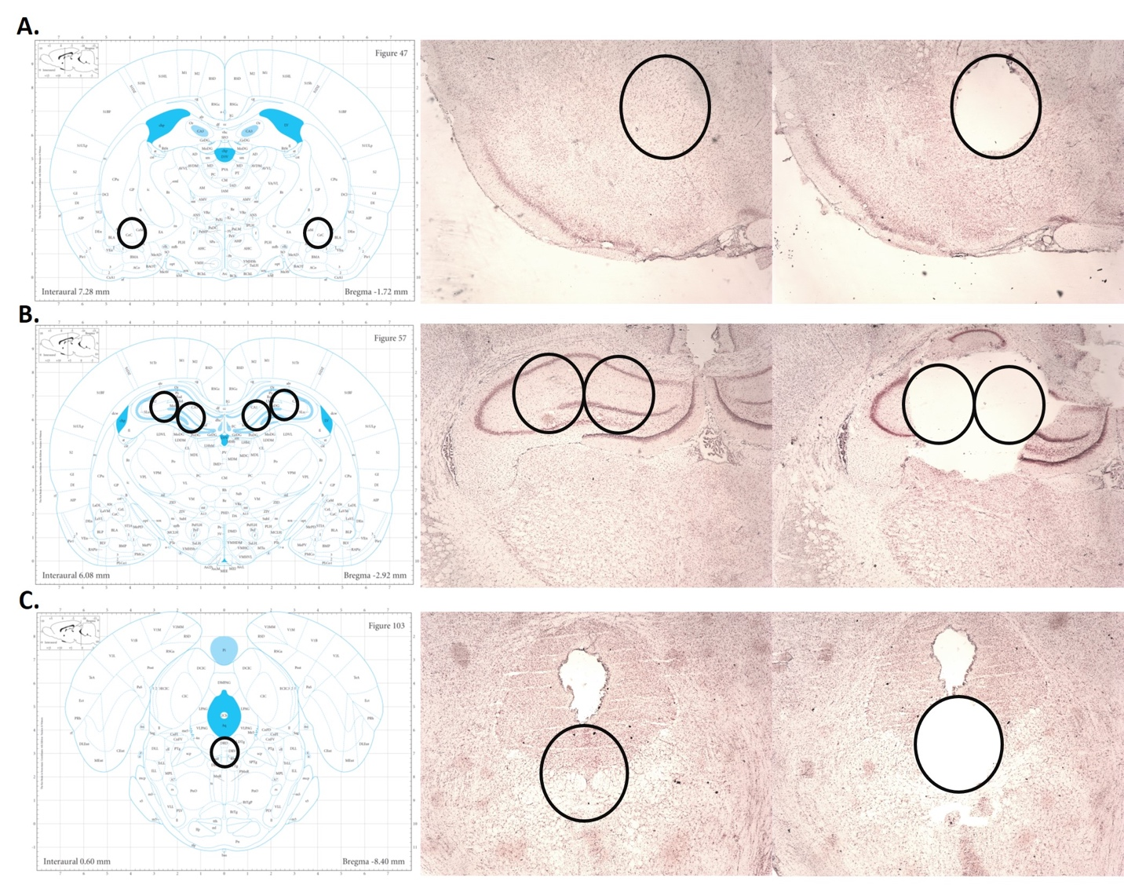

Supplemental Figure 1. Histological verification of punch placement at the level of the (A) CeA, (B) Hippocampus, and (C) DR. The left most panel depicts the Paxinos and Watson Brain atlas used as a reference point for punch acquisition. The center panel depicts the pre-punch slice obtained immediately prior to punch acquisition. The right most panel depicts the post punch slice obtained immediately after punch acquisition. Black circles serve as reference points between each panel to depict ideal punch placement.

Supplemental Table 1. DSP-4 treated rats with a history of stress exposure exhibit no significant difference in cytokine expression in the CeA at rest. Data presented as average pg/mL ± SEM.
Analyte | Vehicle |  | DSP-4 |  | Main Effect of Treatment  (Tx)/Stress
 | Control | Defeat | Control | Defeat
IL-1β | 100.0± 10.8 | 98.1±  3.8 | 108.5± 14.2 | 105.6±  8.7 | Stress: F_{(1,20)}=0.04, p=0.83  Tx: F_{(1,20)}=0.51, p=0.48
IL-2 | 100.0± 14.0 | 100.5±  7.4 | 117.6± 13.0 | 114.9±  9.8 | Stress: F_{(1,20)}=0.01, p=0.93  Tx: F_{(1,20)}=1.70, p=0.21
IL-4 | 100.0±  8.9 | 98.6±  2.4 | 103.9±  10.0 | 106.3±  7.3 | Stress: F_{(1,20)}=0.002, p=0.96  Tx: F_{(1,20)}=0.45, p=0.51
IL-6 | 100.0±  4.5 | 101.6±  2.6 | 99.1±  7.4 | 102.5±  4.7 | Stress: F_{(1,20)}=0.20, p=0.66  Tx: F_{(1,20)}=0.0001, p=0.996
IL-10 | 100.0±  4.2 | 103.8±  1.6 | 106.1±  4.6 | 105.3±  4.0 | Stress: F_{(1,20)}=0.12, p=0.73  Tx: F_{(1,20)}=0.76, p=0.39
IL-13 | 100.0± 11.4 | 112.9±  4.9 | 108.7± 13.1 | 118.7±  9.7 | Stress: F_{(1,20)}=1.01, p=0.33  Tx: F_{(1,20)}=0.41, p=0.53
GM-CSF | 100.0± 12.6 | 108.0± 11.2 | 111.7± 11.9 | 97.1±  6.7 | Stress: F_{(1,20)}=0.10, p=0.76  Tx: F_{(1,20)}=0.001, p=0.97
INF-g | 100.0± 11.3 | 106.9±  7.0 | 102.9± 18.1 | 108.6±  13.8 | Stress: F_{(1,19)}=0.17, p=0.68  Tx: F_{(1,19)}=0.02, p=0.88
TNF-a | 100.0±  4.1 | 93.4±  3.9 | 96.3±  4.6 | 91.6±  1.9 | Stress: F_{(1,20)}=2.37, p=0.14  Tx: F_{(1,20)}=0.56, p=0.46

Supplemental Table 2. DSP-4 treated rats with a history of stress exposure exhibit differences in cytokine expressions in the DR at rest. Data presented as average pg/mL ± SEM.
Analyte | Vehicle |  | DSP-4 |  | Main Effect of Treatment  (Tx)/Stress
 | Control | Defeat | Control | Defeat
IL-1β | 100.0± 22.6 | 97.7±  16.9 | 151.5± 7.6 | 137.5±  9.6 | Stress: F_{(1,17)}=0.36, p=0.55  Tx: F_{(1,17)}=11.56, p<0.01
IL-2 | 100.0± 23.9 | 110.1± 11.9 | 152.8± 14.3 | 135.9±  16.4 | Stress: F_{(1,17)}=0.04, p=0.85  Tx: F_{(1,17)}=4.99, p<0.05
IL-4 | 100.0±  9.8 | 109.3±  15.7 | 138.7±  7.0 | 126.9±  7.9 | Stress: F_{(1,17)}=0.02, p=0.90  Tx: F_{(1,17)}=8.16, p<0.05
TNF-a | 100.0± 9.0 | 97.5± 10.9 | 116.5± 4.2 | 115.8±  9.9 | Stress: F_{(1,17)}=0.03, p=0.87  Tx: F_{(1,17)}=3.25, p=0.09
Supplemental Table 3. Comparison of plasma, central amygdala (CeA) and dorsal raphe (DR) cytokines of resting non-stress controls (NSC) and rats exposed to a single social defeat challenge (SDC). Data presented as the mean pg/mL cytokine concentration ± SEM. ND is used in instances where cytokine values fell below the limit of detection. *p<0.05; **p<0.01, ****p<0.0001
Plasma | IL-1β | IL-4 | IL-6 | IL-10 |  | TNF-α
NSC | 48.4±4.8 | 20.2±2.4 | 232.8±24.7 | 172.2±15.9 |  | 37.0±3.5
SDC | 178.7±47.3* | 1072.0±288.0* | 208.1±66.1 | 353.1±93.0* |  | 616.4±252.2*
t-test results | t₍₅₎=2.7 | t₍₅₎=3.7 | t₍₆₎=0.7 | t₍₅₎=1.9 |  | t₍₅₎=2.27
CeA | IL-1β | IL-4 | IL-6 | IL-10 |  | TNF-α
NSC | 5.6±1.0 | 0.4±0.1 | 13.8±1.8 | 3.8±0.7 |  | 0.4±0.03
SDC | 11.7±2.4 | 1.7±0.3* | 17.5±1.0 | 13.2±2.5* |  | 32.4±6.9*
t-test results | t₍₄₎=2.3 | t₍₄₎=4.3 | t₍₄₎=1.8 | t₍₄₎=3.6 |  | t₍₅₎=4.6
DR | IL-1β | IL-2 | IL-10 |  | MCP-1
NSC | 18.6±0.7 | 31.8±2.6 | 66.2±2.2 |  | 36.1±1.2
SDC | 3.1±0.3**** | 11.15±0.5** | 46.3±3.4** |  | 22.0±0.8****
t-test results | t₍₄₎=20.1 | t₍₄₎=7.8 | t₍₅₎=4.9 |  | t₍₅₎=9.7

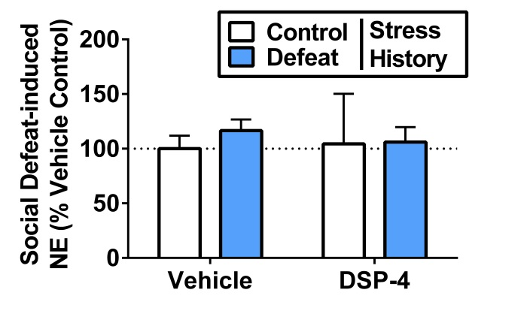
Supplemental Figure 2. NE content in the DR following the acute defeat challenge was unaffected by stress history (Effect of Stress: F(1,16)=0.2, p=0.7) or treatment condition (Effect of Treatment: F(1,16)=0.02, p=0.9).

